Chain of Responsibility

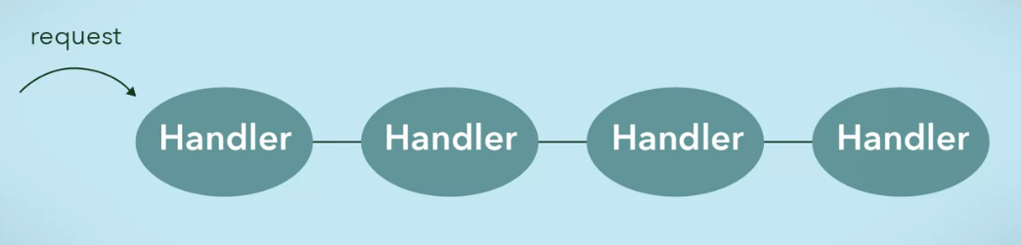

If cannot deal with the request, it will send the request to the next handler

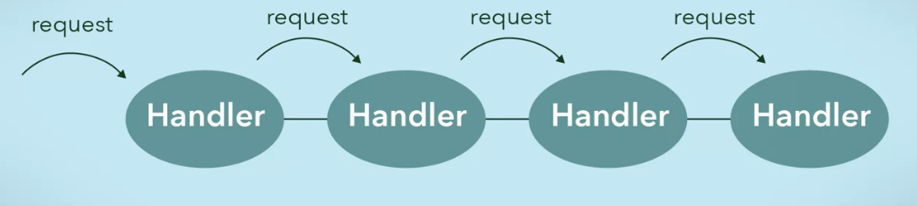

If no handler can process it, then request is not satisfied

Similar to **Exception Handling in Java**

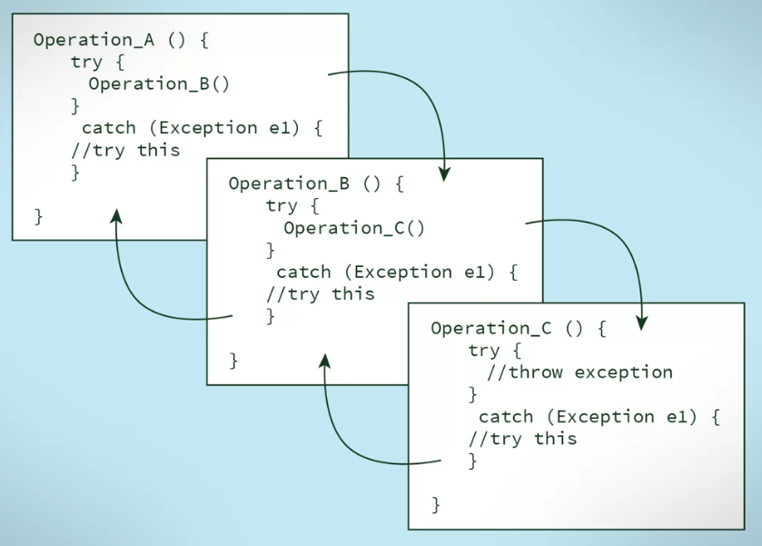

Email filters

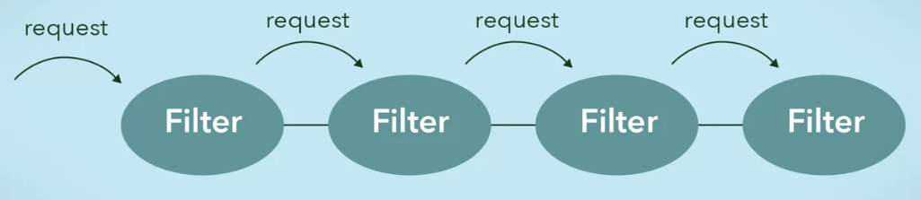

UML Diagram

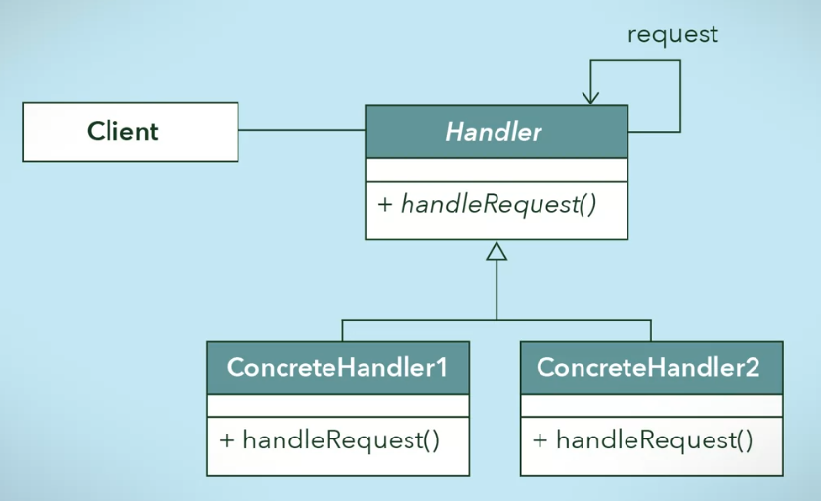

Issue in this design

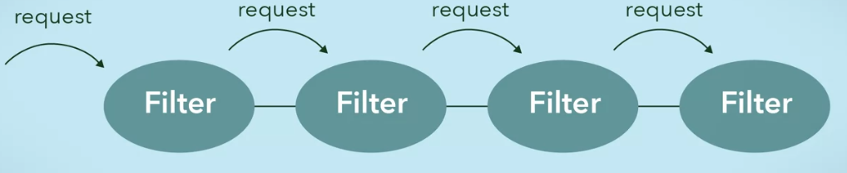

* We need to make sure that each filter goes to each

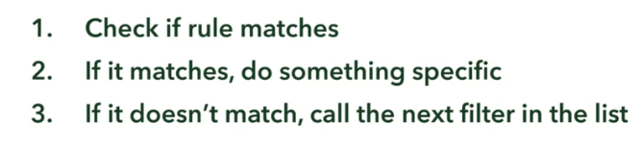

* To achieve this, use a **Template Pattern** to handle request in this kind of way **uniformly**